# PROJECT REPORT TEMPLATE

Build a event management system using salesforce

# Introduction

* 1. Overview

Dear students,

By internal marks it meams that your marks obtained by your assignment or other co-curricular activites or your behavior most important. It is the marks that is given by your teacher to you.The marks you obtained in your exam or theory is external marks. For partical exam there is both internal marks and external marks.

* 1. Purpose

1. Offers the possibility of adssessing more complex and important aspects of a learning areas or subject matter that can not be assessed through traditional form of testing .
2. Provides a profile of learner’s abilities- in depth growth and progress.
3. Serves as a concrete vehicle for an ongoing communication or exchange of information and feedback among various stakeholders – students, peers, teachers, administrators. It may even be used to compare achievement across classrooms or schools;
4. Serves as a lens and helps to develop among students an awareness of their own learning.
5. Provide an opportunity to share own learning with peers and review and give feedback on each other’s work.
6. Peer Assessment thus becomes a great support that further facilities a clear understanding and evaluation of personal goals.

# Problem Definition & Design Thinking

* 1. Empathy Map

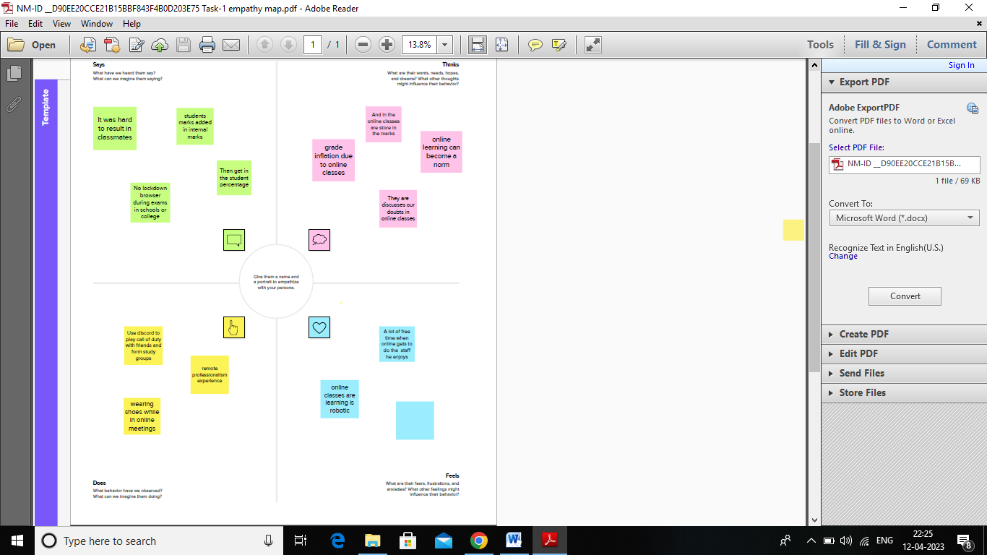

* 1. Ideation and Brainstorming Map

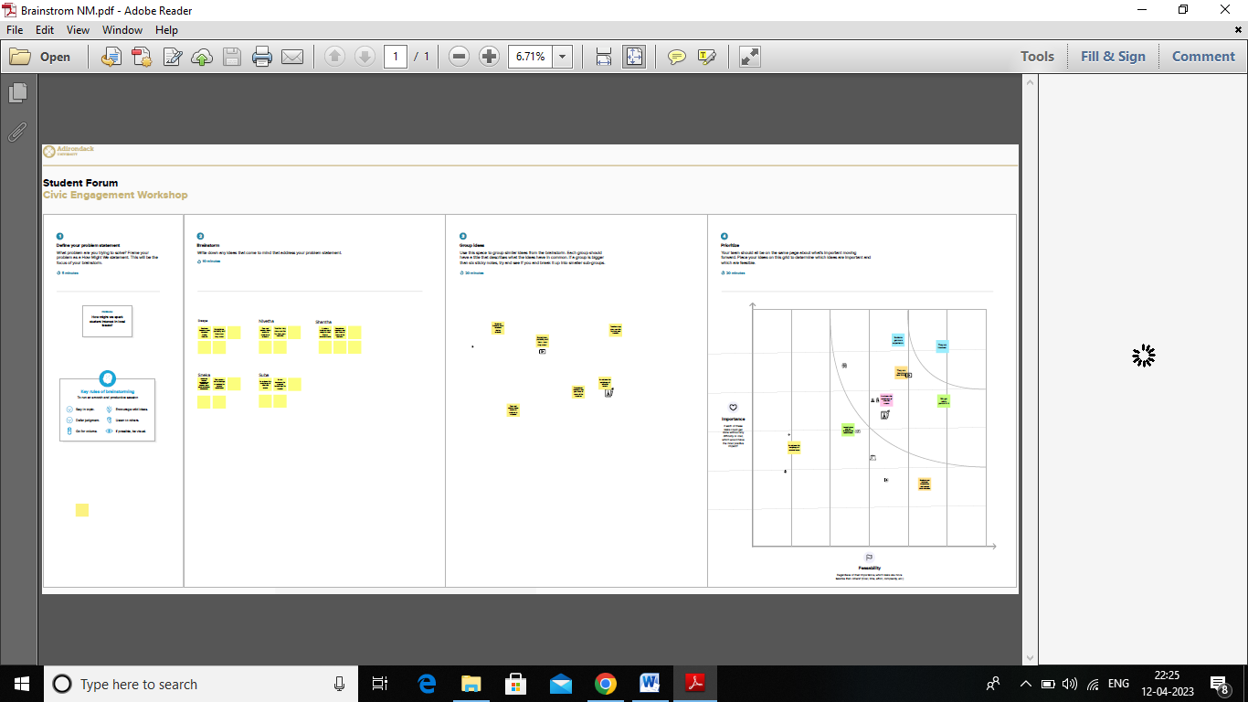

# Result

* 1. Data Model

|  |  |  |  |  |
| --- | --- | --- | --- | --- |
| Object Name | Fields in the object | | | |
| Semester Name |  | **Field label** | **Data type** |  |
| Semester Name | Text |  |
| Course | Text |  |
|  |  |  |
| Candidate |  | **Field label** | **Data type** |  |
| Candidate Name | Text |  |
| Candidate ID | Text |  |
| Semester Name | Text |  |
| Course Details |  | **Field label** | **Data type** |  |
| Course Name | Text |  |

|  |  |  |  |  |
| --- | --- | --- | --- | --- |
|  |  | Internal Results | Text |  |
| Lecturer |  | **Field label** | **Data type** |  |
| Lecturer role | Text |  |
| Lecturer Name | Text |  |
| Course ID | Text |  |
| Course | Text |  |
| Internal Results |  | **Field label** | **Data type** |  |
| Candidate,Course ID,Marks | Text |  |

* 1. Activity and Screenshot

# Milestone 1:

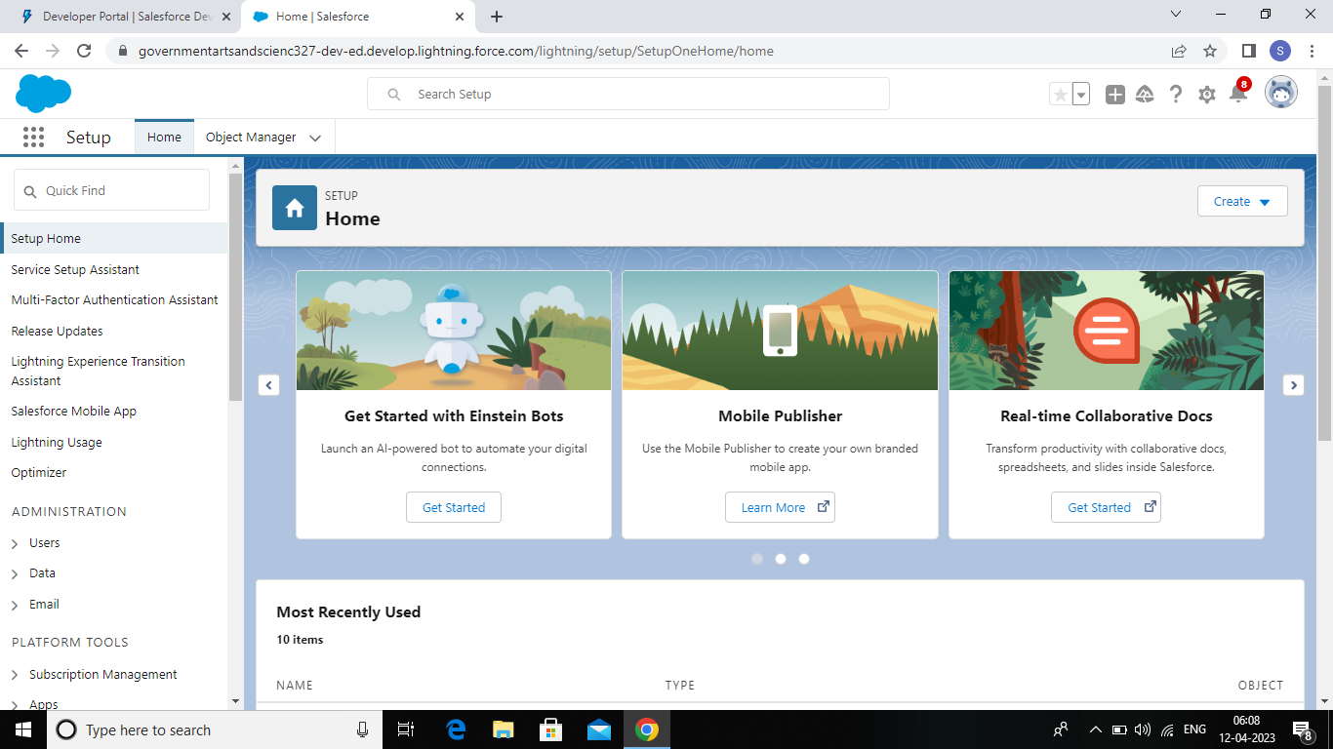

**Milestone 2:- Object**

Activity 1:

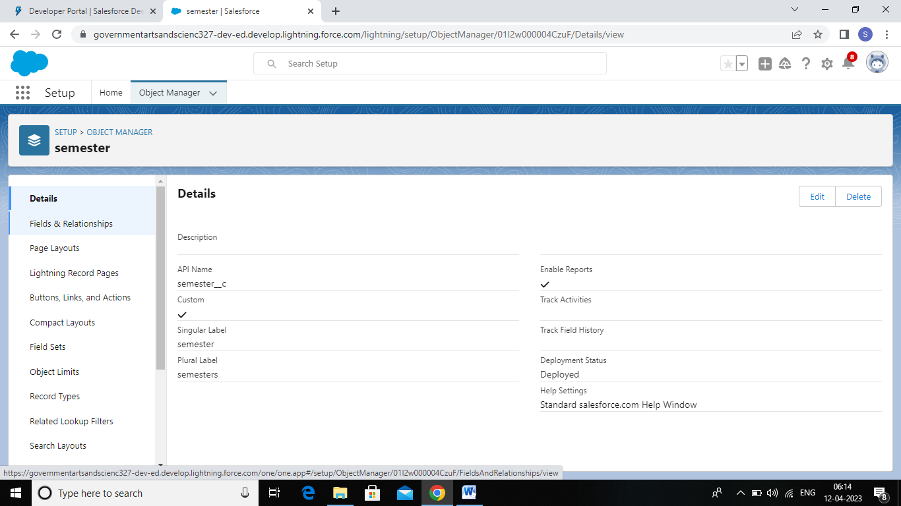

Activity 2:

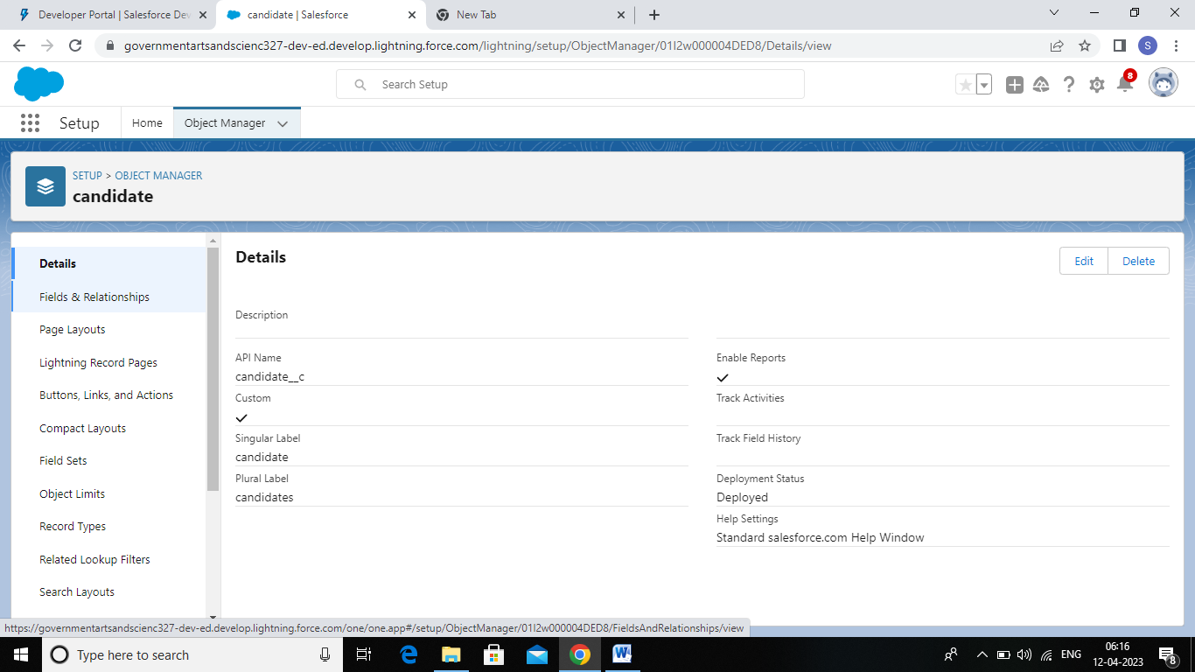

Activity 3:

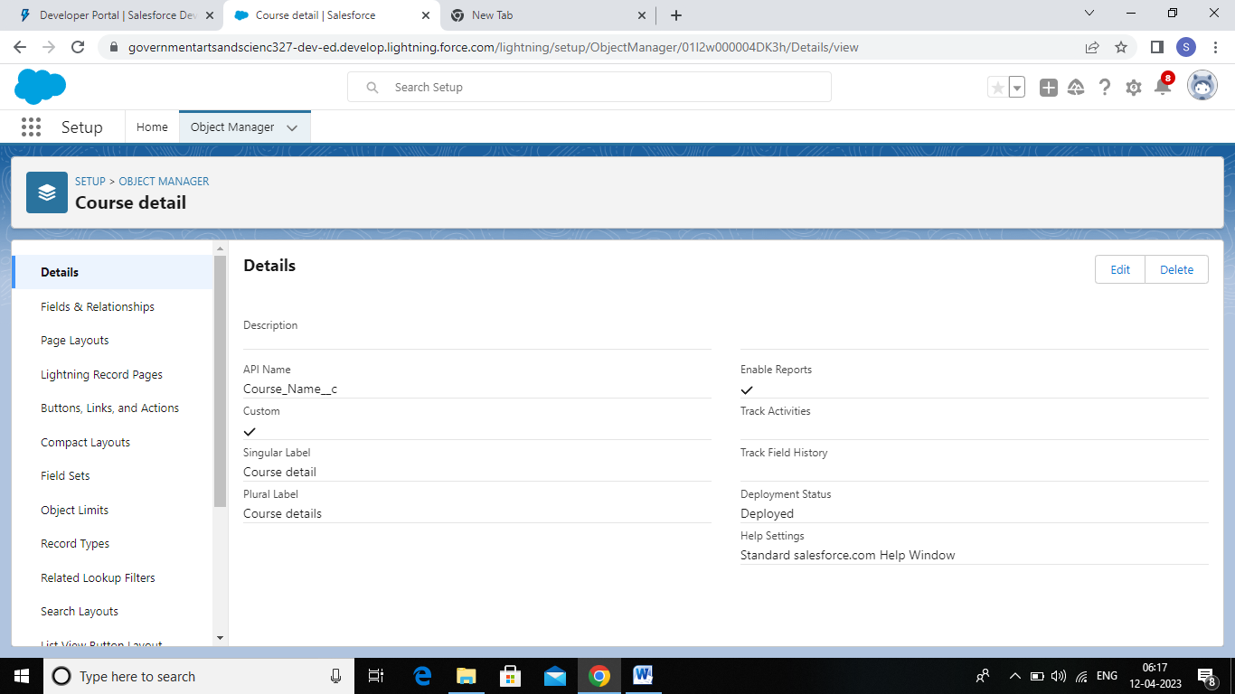

Activity 4:

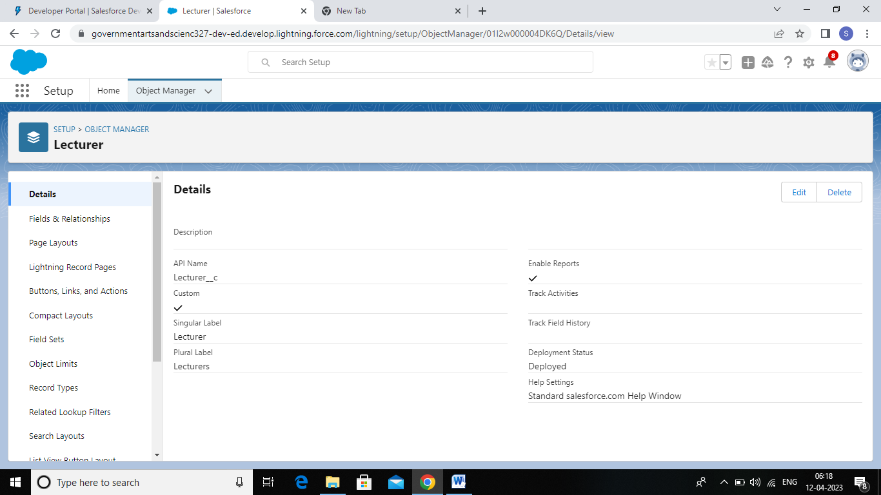

Activity : 5

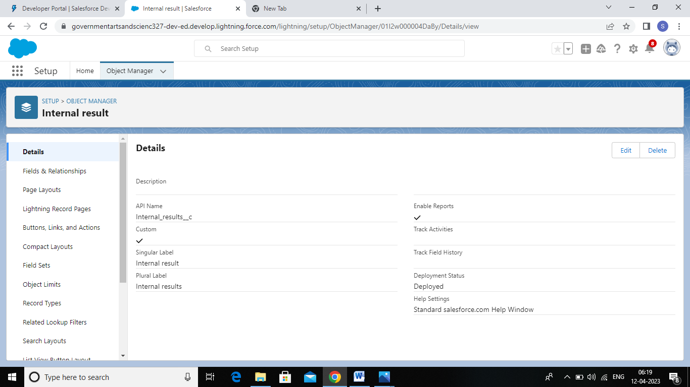

# Milestone 3:- Tab

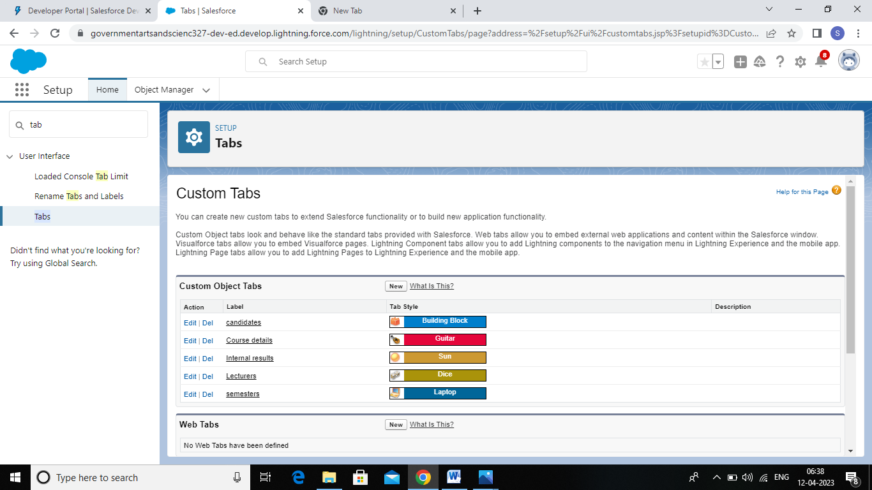

Activity 1: Creation of Semester Tab

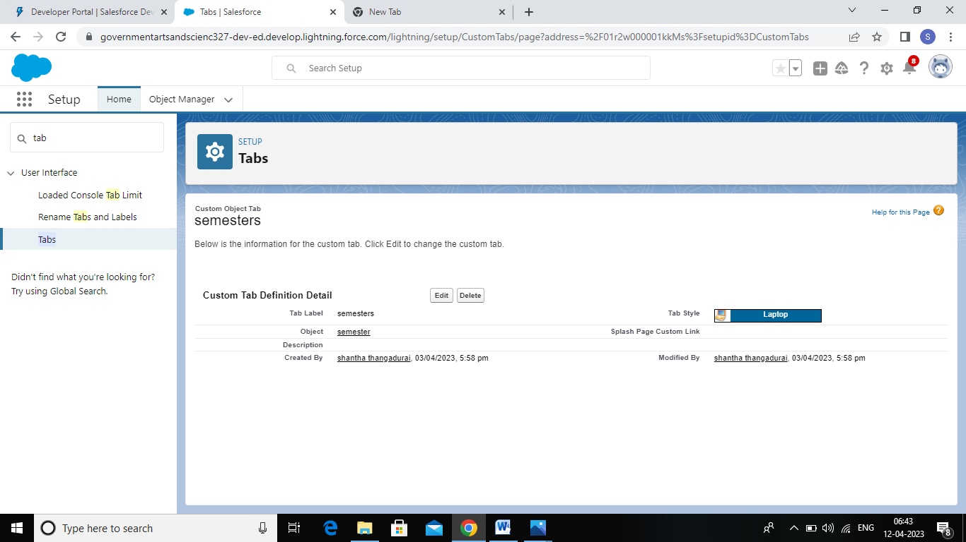

Activity 2: Creation of Candidate Tab

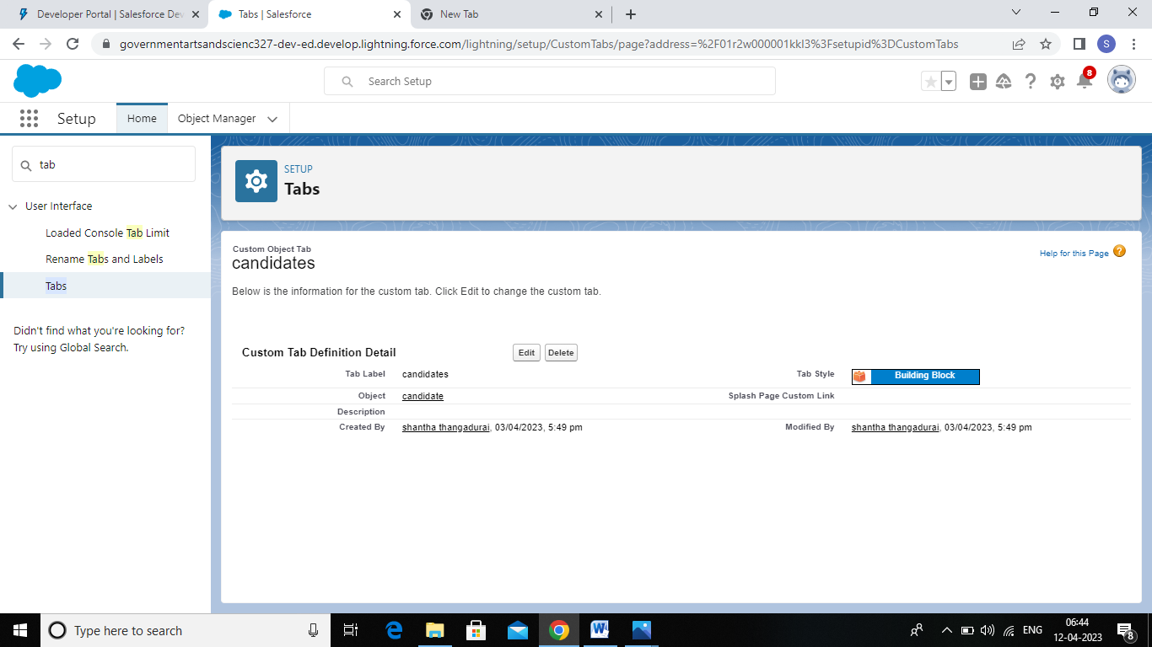

Activity 3: Creation of Course Detail Tab

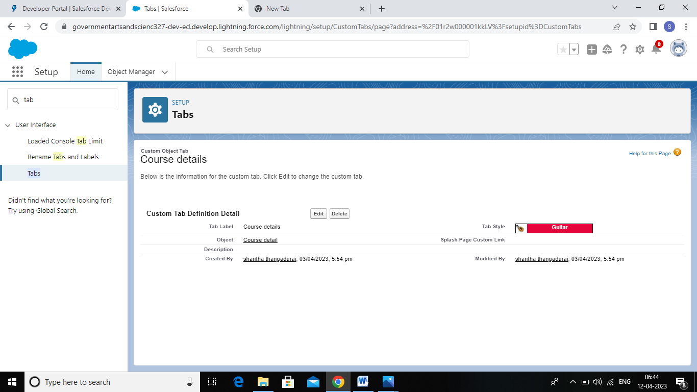

Activity 4: Creation of Lecturer Tab

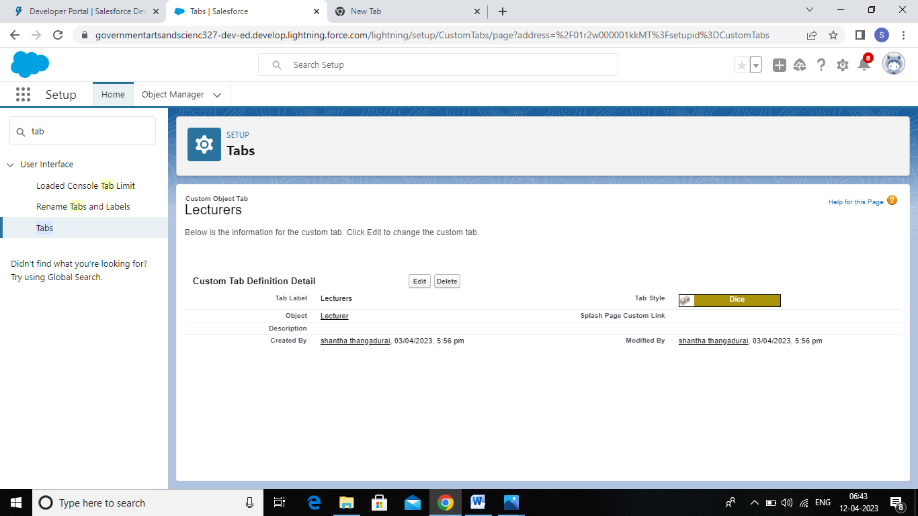

Activity 5 : Creation of Internal Results Tab

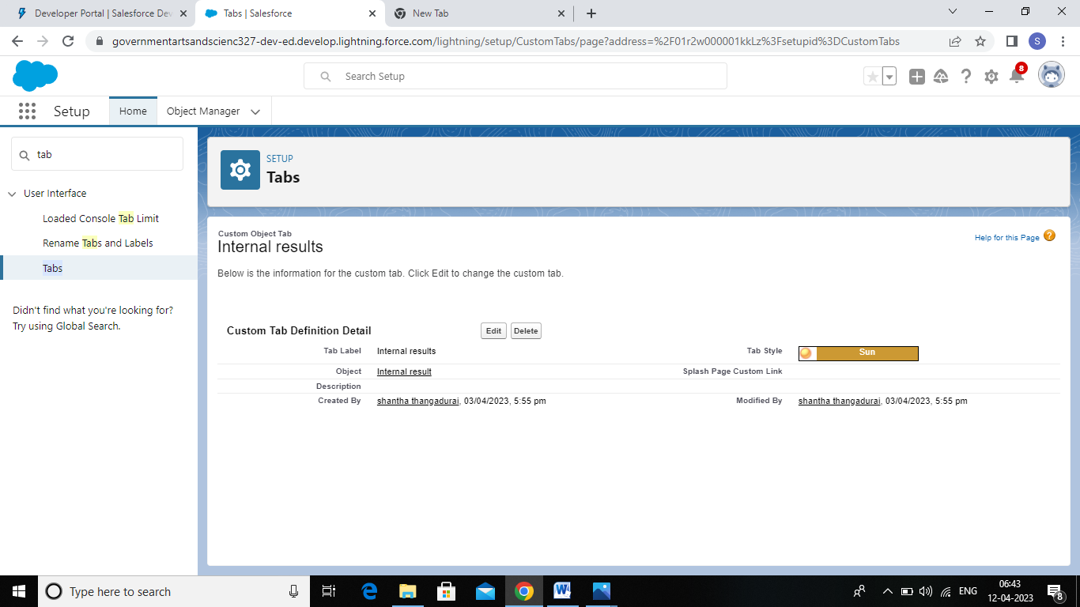

# Milestone 3 :- Application

Activity 1: Create the Semester App

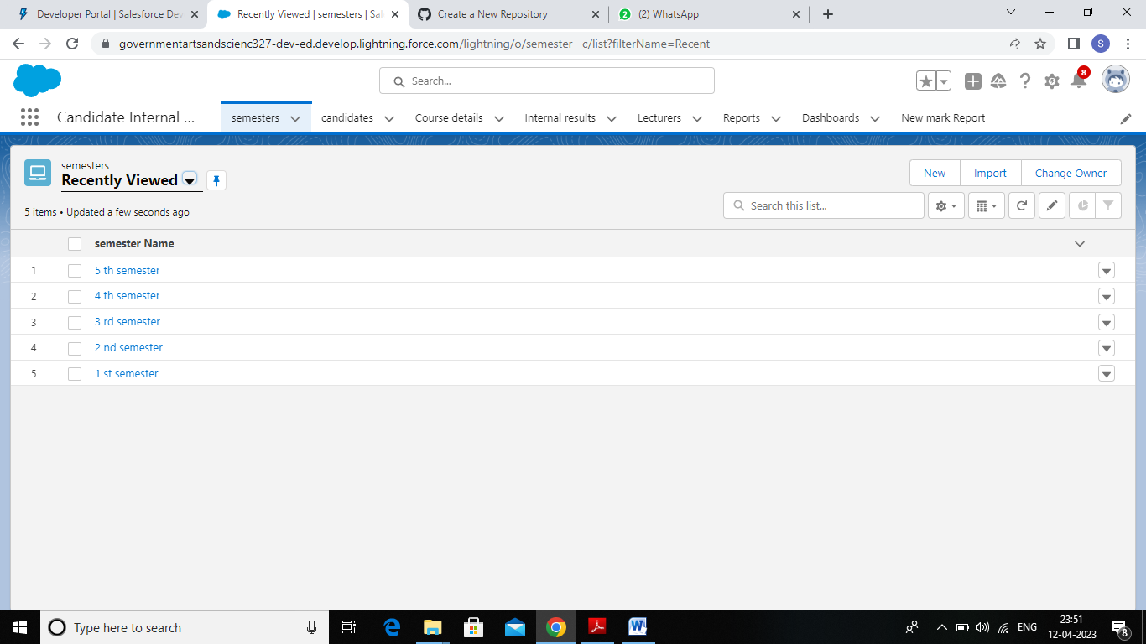

# Activity 2 : Create the Candidate App

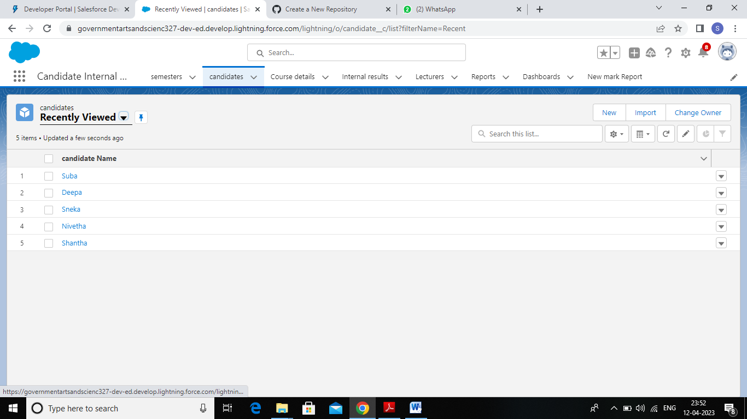

# Activity 3 : Create the Course Detail App

# 

# Activity 4 : Create the Lecturer App

# 

# Activity 5 : Create the Internal Results App

# 

# Milestone 4:- Fields

Activity 1: Creation of Fields for the Semester objects

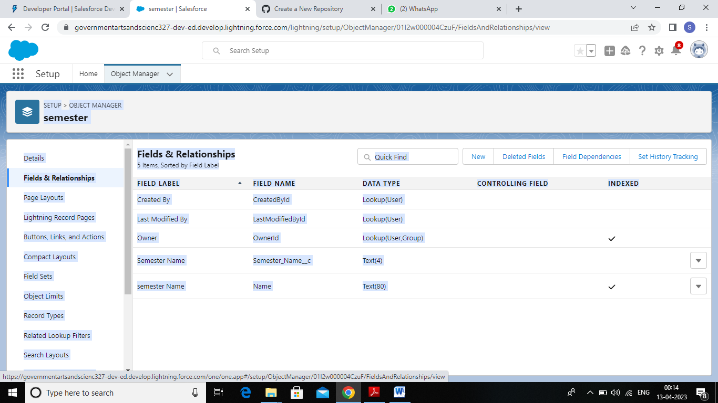

Activity 2: Creation of Fields for the Candidate objects

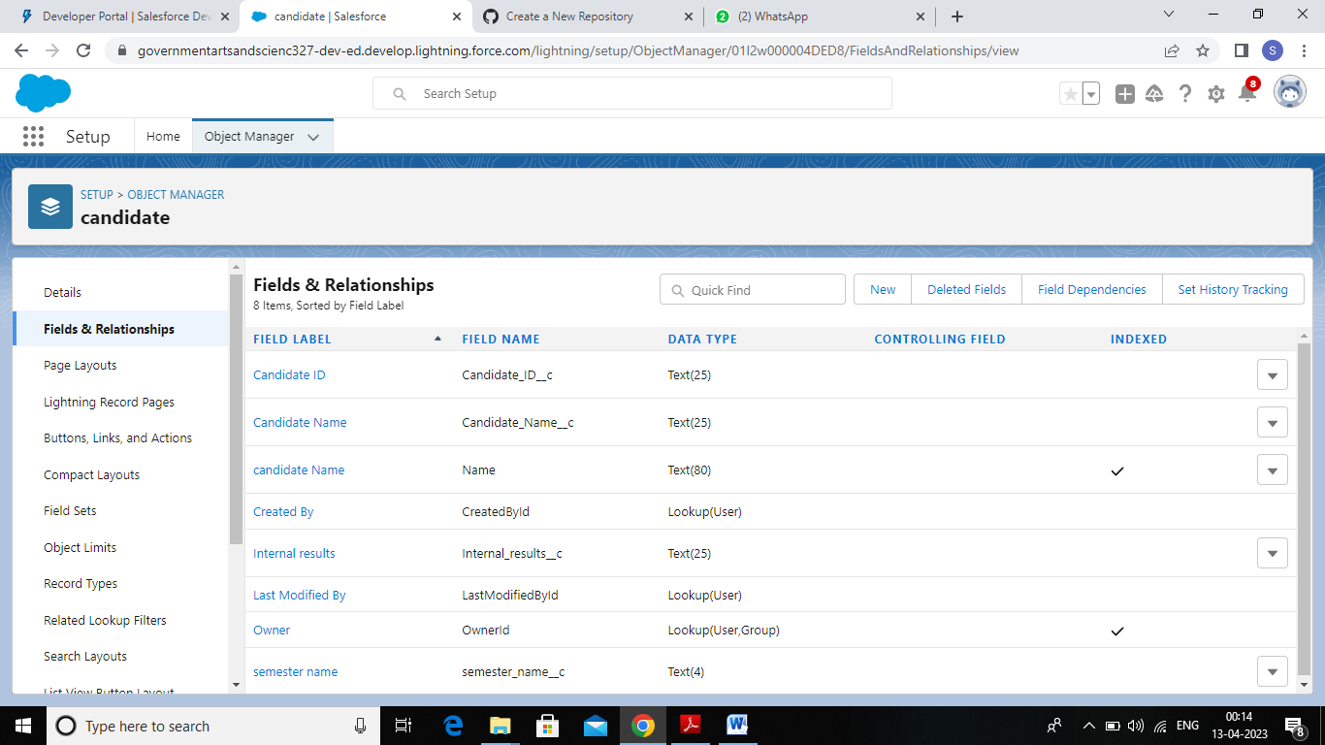

# Activity 3 : Create the Field for Course Detail Objects

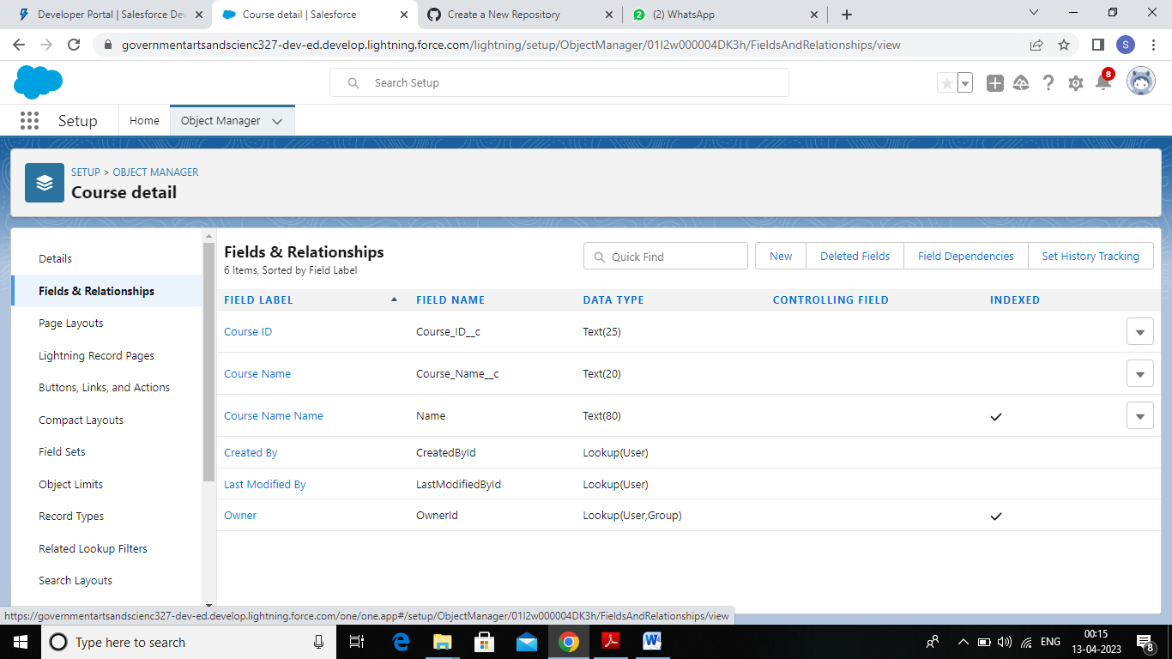

Activity 4: Creation of Fields for the lecturer objects

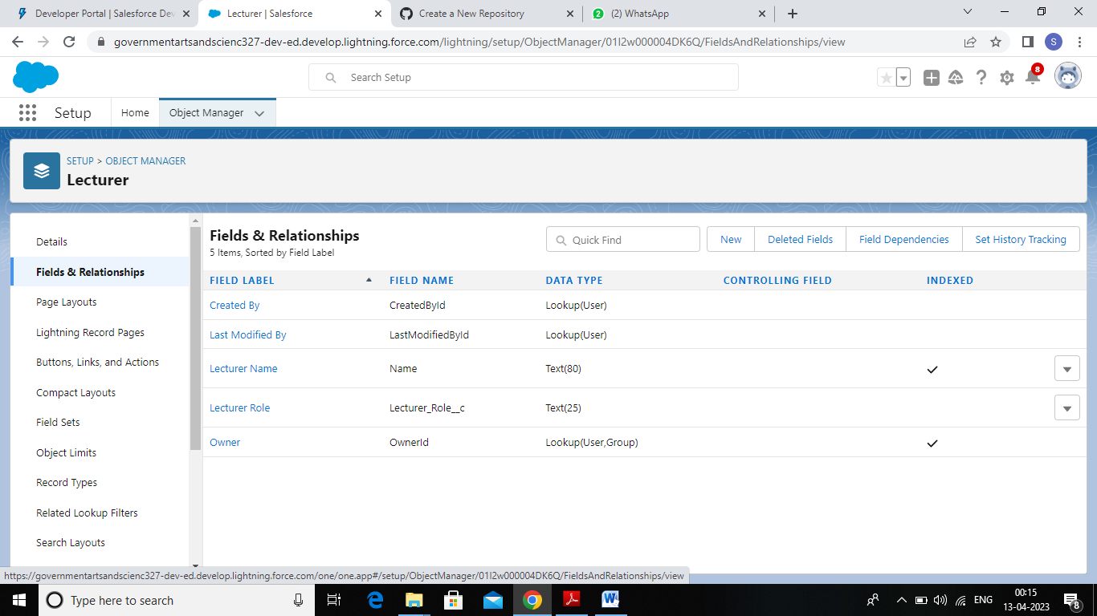

Activity 5: Creation of Fields for the Internal Results objects

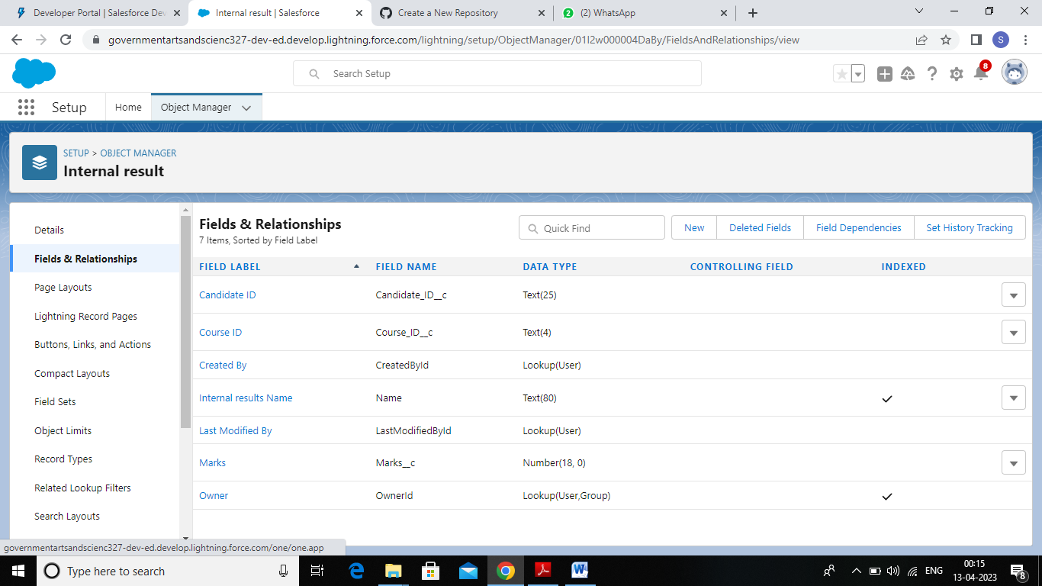

# Milestone 5:- Profile

Activity 1: Creation on event user profile

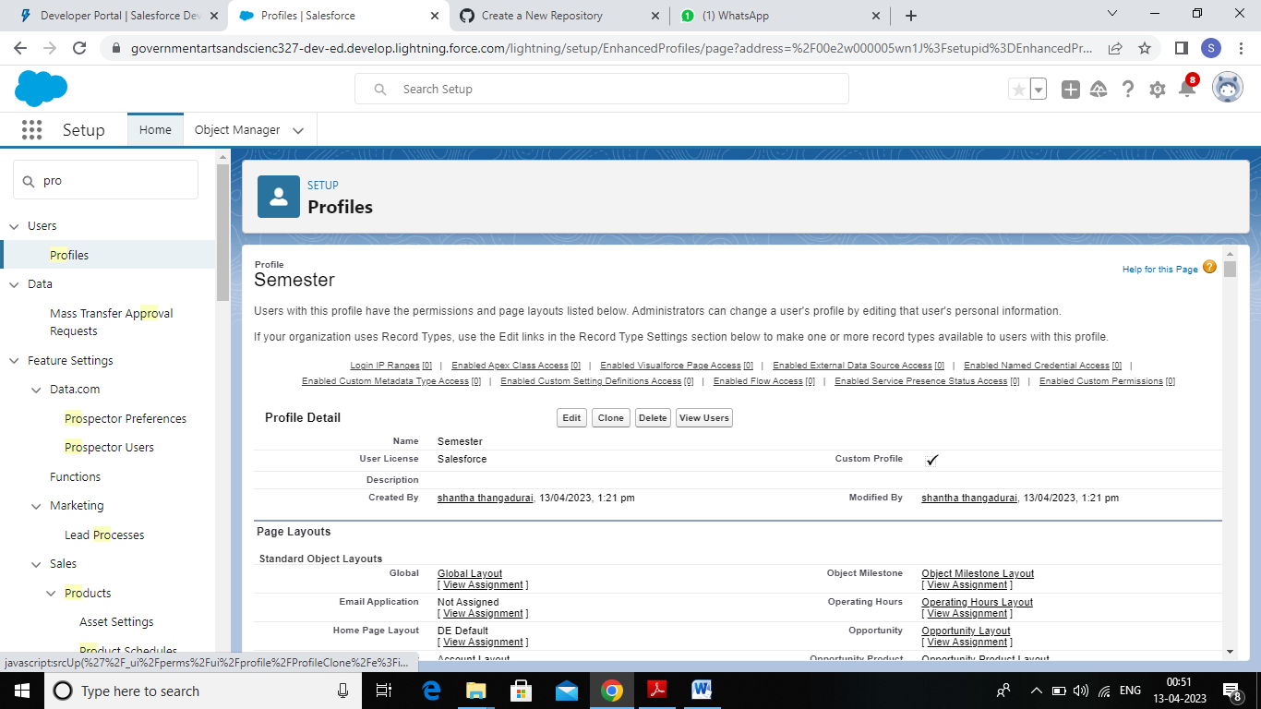

Activity 2: Creation on Candidate profile

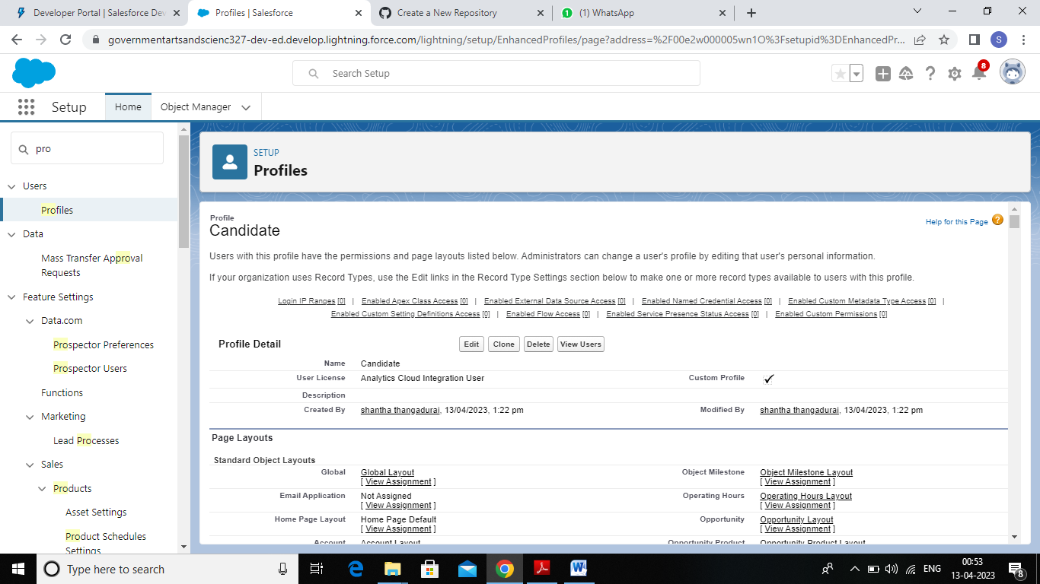

Activity 3 : Creation on Course Detail profile

# 

Activity 4 : Creation on Lecturer profile

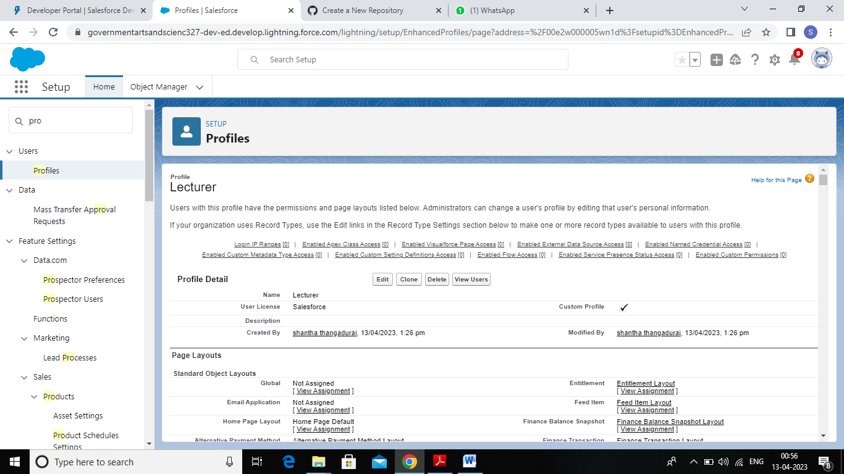

Activity 5 : Creation on Internal Result profile

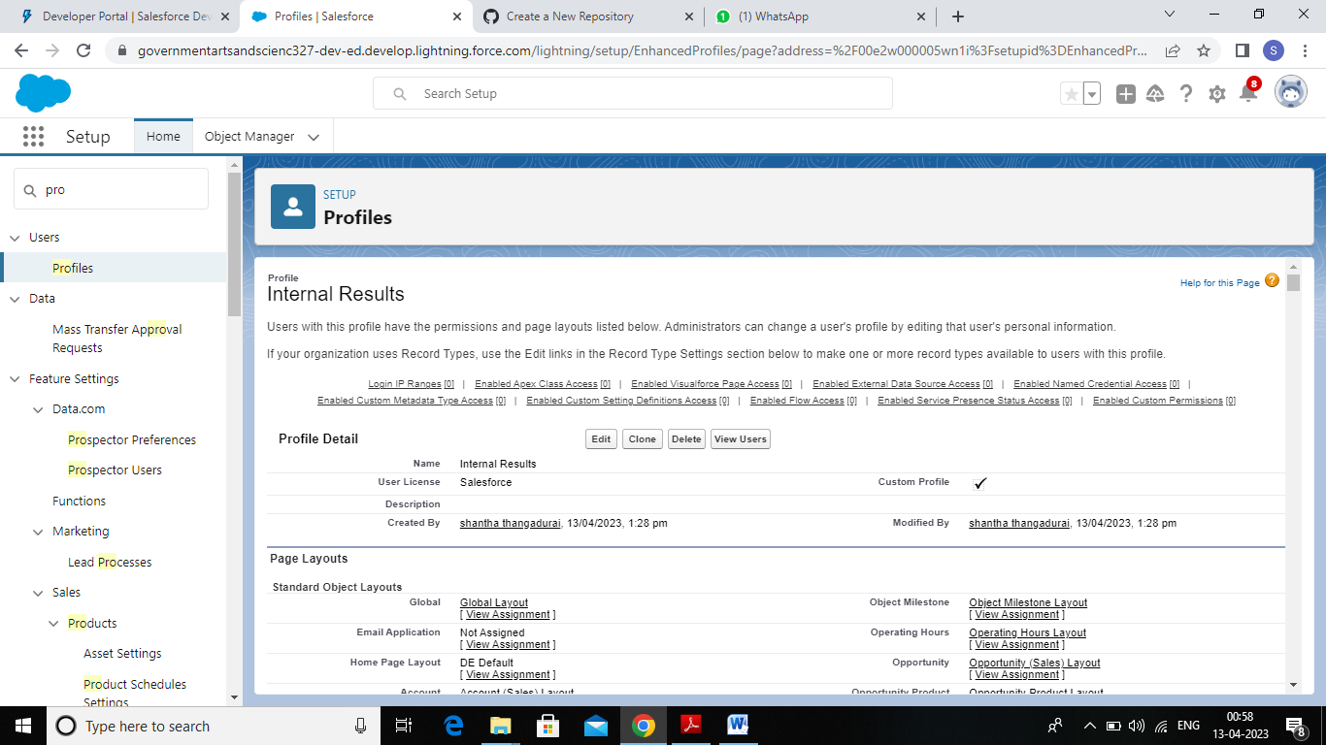

# Milestone 6:- User

Activity 1: Creating a User with username as Shantha thangadurai

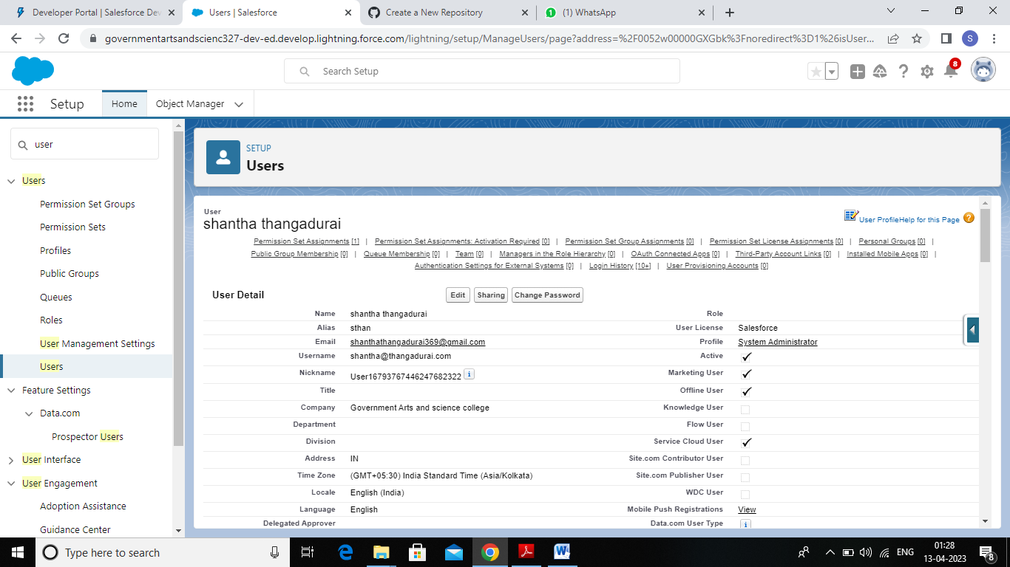

Activity 2: Creating a User with username as Nivetha Amutha

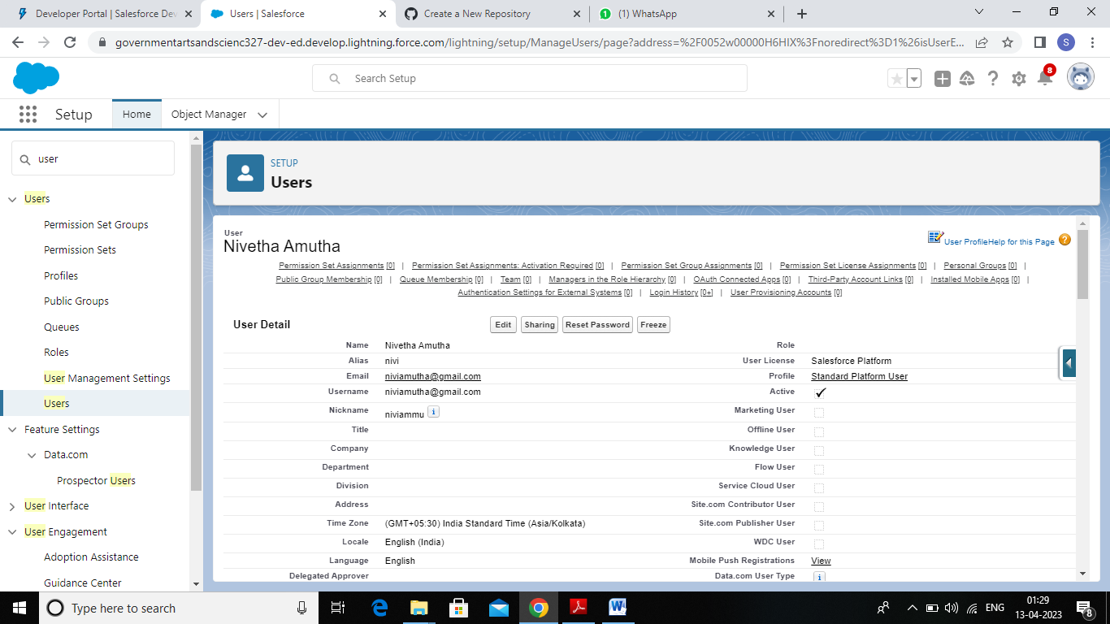

Activity 3 : Creating a User with username as Sneka Sankar

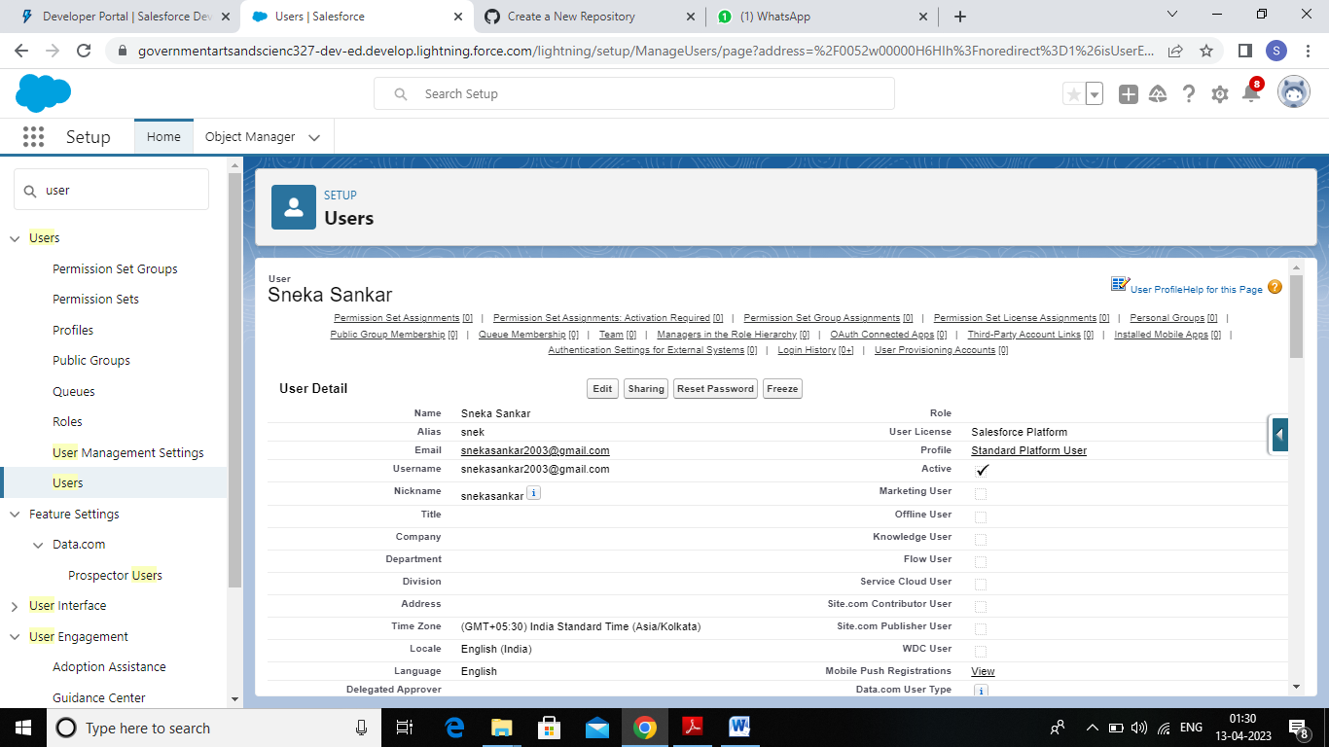

Activity 4 : Creating a user with username as Suba Kasi

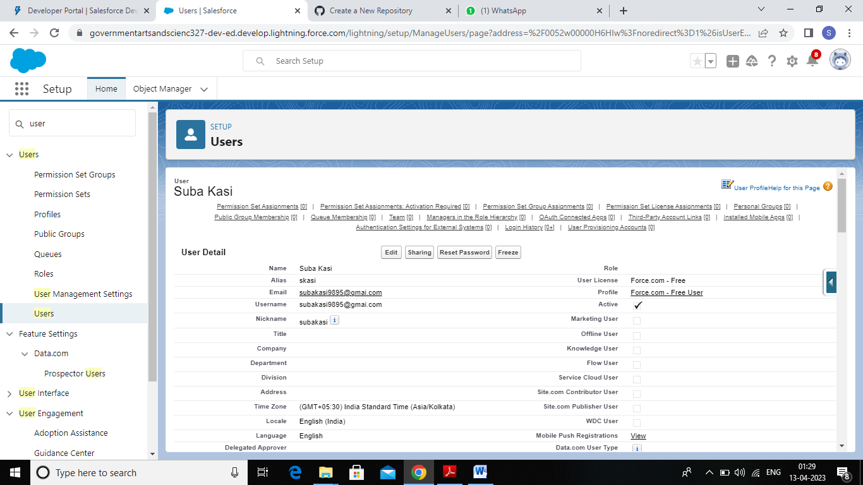

Activity 4 : Creation a user with username as Deepa Annadurai

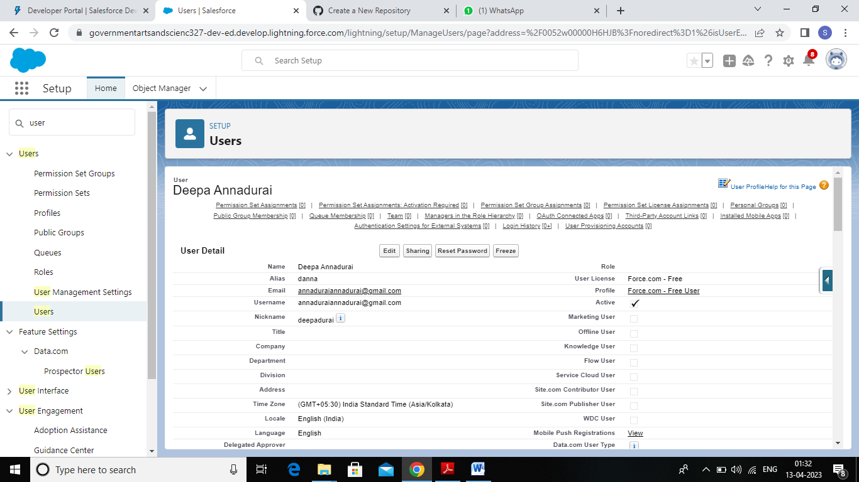

# Milestone 7:- Reports

Creating a Report:

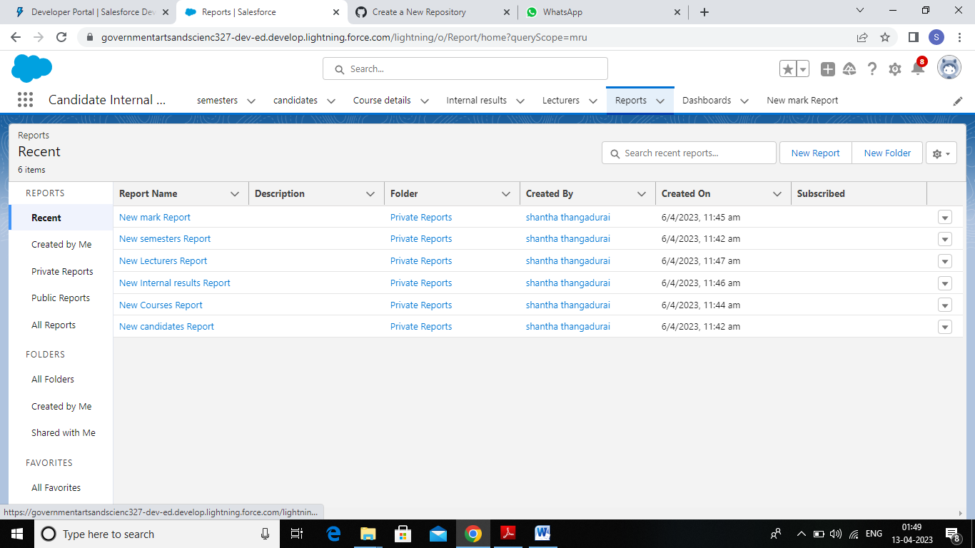

# Trailhead Profile Public URL

TEAM LEAD: SHANTHA .T

https://trailblazer.me/id/sthangadurai

TEAM MEMBER 1: NIVETHA.A

https://trailblazer.me/id/nammu18

TEAM MEMBER 2: SNEKA.S

https://trailblazer.me/id/ssneka5

TEAM MEMBER 3: SUBA.S

https://trailblazer.me/id/ssuba49

TEAM MEMBER 4 : DEEPA.A

https://trailblazer.me/id/tdeepa10

# 5 Advantages and Disadvantages

List of Advantages

* Its reduces the weight age of external assessment.
* Moreover,stundents engage themselves in study throughout the year.
* The students will be more attentive to studying in class.
* In addition, it reduces the chances of anxiety and nervous breakdown in students.

List of Disadvantages

* Sometimes, partiality and bias-ness may occur.
* Teachers may miss-use this for their own benefits.
* Sometimes, teachers may give hints to some of the student.
* The causes a lack of courage in students for external examinations.

# Applications

* + I had put in a lot of effort and I expected better marks than what has been awarded to me.
  + I would resquest you to please recheck my answer sheet.
  + I hope to secure better marks then 50% which has been given to me.
  + I have deposited the necessary amount for the re- verification fees at the accounts counter.

# Conclusion

Do not mess with your teachers. Try to be innocent in her eyes (although you may not be actually).Maintain you impression.Sumit notebooks in time. Period Do not take any quizzes/viva tests(if they happen) too lightly.Have loads of fun in school but do not get caught doing anything suspicious.

# Future scope

* There are manyopportunities if one does his articels solely in internal audit.
* If you want to go to place your self in industry there are many sectors which will hire you in their IAD (Internal Audit Department) either as like strategy and controls reviewers or Internal Process Auditors.
* ITC and Adthiya Birla pays you high in case of indian MNC’s but to get in requires a rank.
* Likewise you can build your repution and increase your firm potential to greater heights.
* All the very best for your future.